Beware of ads and commercial presentations

Diets and ads for enhanced beauty should not to be taken too literally. But since I am already a man of comfortable weight and also not the worst looking guy on the block, I do not usually immerse myself in those particular ads. On the other hand, I read quite a lot of technical magazines and there are no problems there, or is there? Generally not, but you have to be careful… Sometimes it gets very wrong and since this is mostly all about periphery, we start there. The mains voltage is often accused of being the culprit and it shows that ads in trade journals cannot be trusted, either. Here is a compilation that appeared a few years ago:
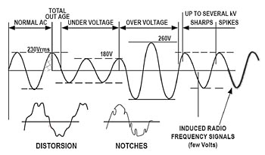
The picture speaks for itself. To me, it is difficult to accept that the normal mains voltage has a peak value of 230 V. The fact that it is also stated as “effective value (RMS) effective value does not make things better. And what is "Out Age"? Is it old power? Or is it possibly meant to say Outage, i.e. interruption? In that case, one should look a little closer at the definition of interruption. A quarter of a period is not an interruption.

The distortion is shown as a waveform that is hardly possible in an electrical network and bears all the signs of being hand-drawn, with a direct current component and peculiar discontinuities. Why not show a typical distorted wave, with flattened peaks and other typical features?
This also applies to "Notches" where the artist magically manages to make time go backwards so that the voltage has double values in the section that appears to be an attack of Leafcutter ants on the sine. An unusually complete collection of misconceptions, I have not commented on all, and leave some as an exercise to the reader. Still, you should give the artist a compliment; he is actually showing a sine wave and not a series of semicircles. Which is not unusual.

Even the simplest and most basic can go wrong The large and trend setting measuring instrument company wants to help us understand the Bode diagram. Like this:
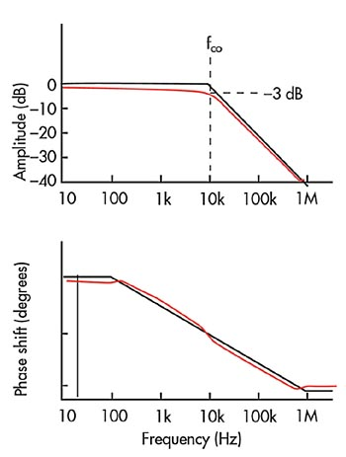

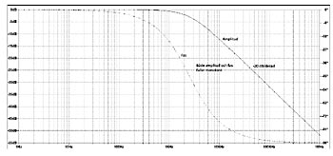
In reality, the Bode diagram looks like above. Admittedly, it is the LT Spice XVII reality, but it is closer to reality than you normally get (sorry for the thin curves - but precision requires thin lines). It may seem strange that a simulation gives a better picture of reality than reality itself. But that is Spice. If you have the right input data, the result is always "right". And, above all, it is much more real than the completely misleading picture in the "pedagogical" presentation from the measuring system manufacturer where both the amplitude curve and, above all, the phase curve are completely up the walls.

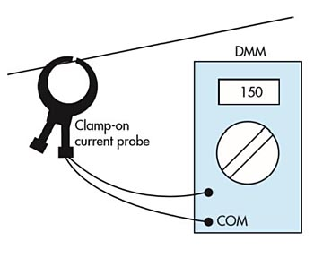

Illustrators with zero knowledge and editors that do not care
Measuring current with a current clamp is a fairly straightforward procedure. Until the following appears in an article in the reputable trade magazine: No comments. But I need to ask: What is being measured? Could it be the diameter of the conductor? Confusion and mistrust are what such "pedagogical" articles spread. And today's designers have an unfortunate tendency to believe more in the miserable presentations of the large instrument company than in their own ability. It's a pitty. And quite often leads to unnecessary doubts and discussions. Trust yourself and think a couple of times before you are “seduced”.

One case where I, myself, fell into the treacherous trap of advertising was when I was fascinated by one of the new programmable combined analog and Cortex 4 systems on a chip. There was also BLE on board and the presentation showed how easy it was to build a rather complex system in one afternoon. That afternoon, I may not have believed in 100%, but in a month or two it should be possible to get a pretty good function. How it turned out? It became a "case" where the Indian support first said that we killed four systems in a row by using a mechanical switch to turn on the power. I pointed out that the inductance in the leads was barely 1 microhenry and if it could kill a well protected supply input, you should probably think again. The case is now over a year old and in total we have lost just over a year. It's significantly more than the two months, not to mention that afternoon, that I was hoping for. In addition, we mixed in a consultant - which hardly helped. Neither time-wise nor financially. The case is still ongoing but I have now switched to another system where most things seem to work. And where advertising is much more restrained.

Conclusion: Advertising is basically good. But you should be a little careful in some cases. And if it feels wrong, it is unfortunately quite often wrong. End of the whining.

Gunnar Skogsgurra Englund, GKE Elektronik AB

